## NoSQL Lab 1

**Question**

Perform the following DB operations using MongoDB.

1. Create a database “Student” with the following attributes Rollno, Age, ContactNo, Email-Id.
2. Insert appropriate values
3. Write query to update Email-Id of a student with rollno 10.
4. Replace the student name from “ABC” to “FEM” of rollno 11.
5. Export the created table into local file system
6. Drop the table
7. Import a given csv dataset from local file system into mongodb collection.

**Create database**

db.createCollection(**"Student"**)*;*

### Create table & Inserting Values to the table

db.Student.insertMany([{**rollno:**1,**age:**21,**cont:**9876,**email:"prannay@gmail.com"**},{**rollno:**2,**a ge:**22,**cont:**9976,**email:"sohan@gmail.com"**},

{**rollno:**3,**age:**21,**cont:**5576,**email:"farhan@gmail.com"**},

{**rollno:**4,**age:**20,**cont:**4476,**email:"sakshi@gmail.com"**},{**rollno:**5,**age:**23,**cont:**2276,**email:"sa nika@gmail.com"**}]);

**Structure**

**of**

**the**

**table**

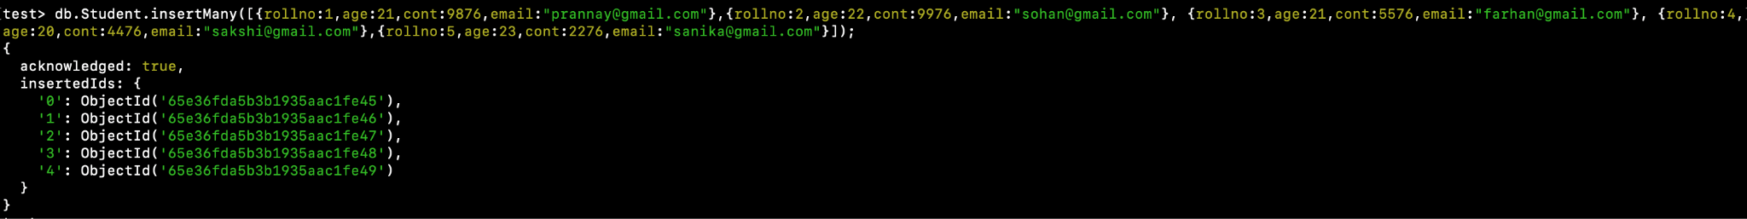

db.Student.find();

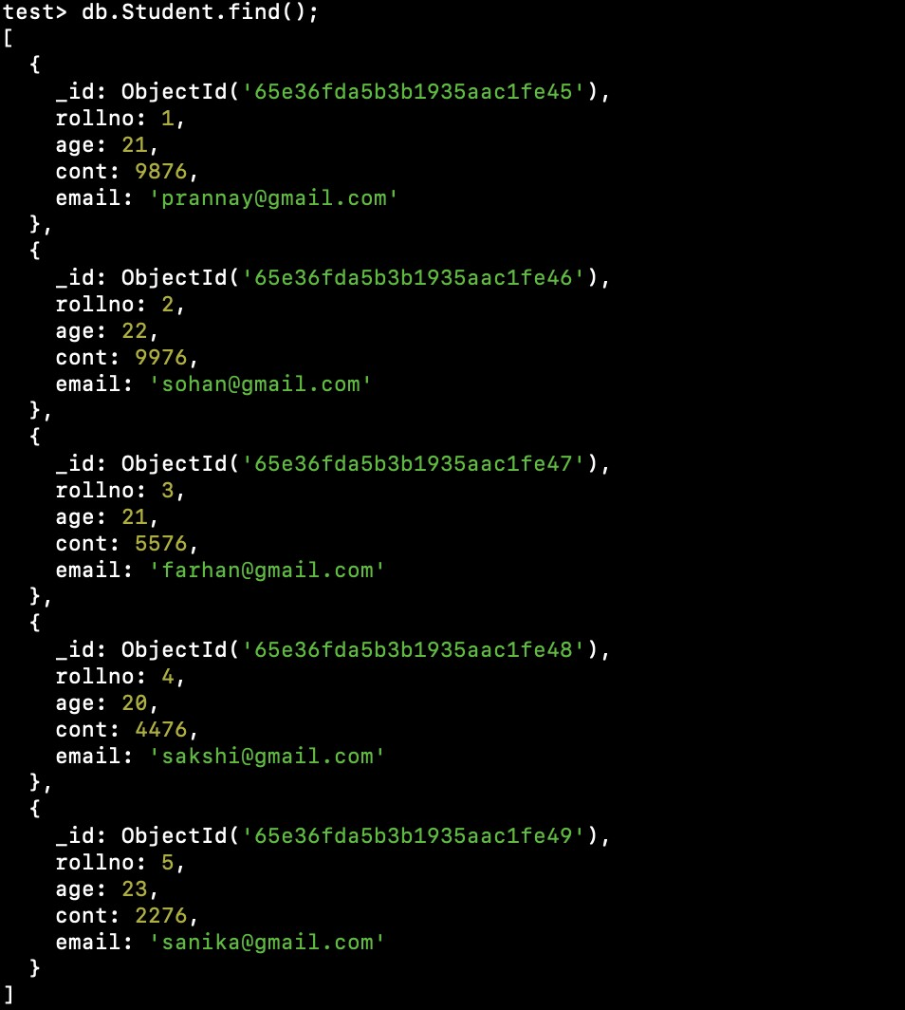

### Queries

* **Write a query to update the Email-Id of a student with rollno 5.**

**db.Student.update**({**rollno**:5},{$**set**:{**email**:**"abhinav@gmail.com"**}});

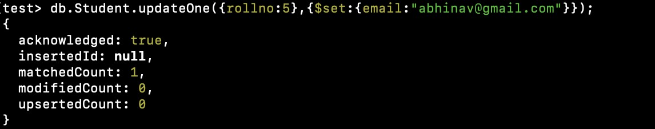

* **Replace the student name from “ABC” to “FEM” of rollno 11.**

**db.Student.insert**({**rollno**:11,**age**:22,**name**:**"ABC"**,**cont**:2276,**email**:**"madhura@gmail.com"**}); **db.Student.update**({**rollno**:11,**name**:**"ABC"**},{$**set**:{**name**:**"FEM"**}})

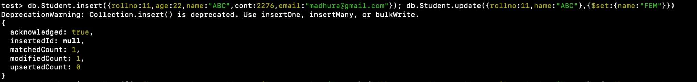

* **Drop the table**

db.Student.drop();



* **Import a given csv dataset from local file system into mongodb collection.**

mongoimport mongodb+srv://204:<password>@cluster0.xbmgopf.mongodb.net/test

db.Student.find();

